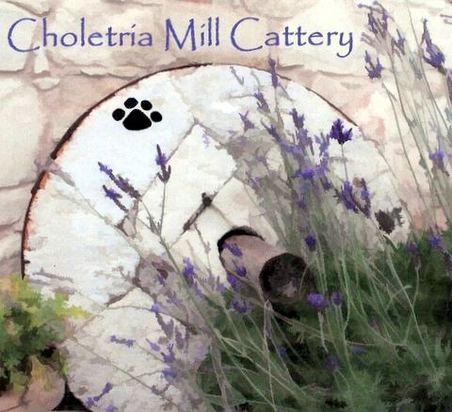 Choletria Mill Cattery

MEDICAL CONSENT & LEGAL CONDITIONS OF BOARDING

I fully consent to my cat(s) being transported to a veterinary surgeon for both pre-arranged and acutely necessary appointments. I also fully consent to emergency or necessary veterinary treatment including examination, biopsy, medications (including injections) or surgery should my cat(s) in the opinion of a veterinary surgeon require it during my absence, and that I will fully refund the total costs upon my return.

Signature of Owner………………………………………………………………………………………………..

Print Name………………………………………………………………………………………………………………..

Date…………………………………………………………………………………………………………………………….

Whilst every reasonable effort will be made to contact the owner of any cat(s) that fall ill, are injured or die whilst being boarded, or in the opinion of a veterinary surgeon requires necessary treatment or surgery, the cattery cannot for whatever reason be held legally responsible for not being able to make such contact.
The cattery will not accept any legal liability or responsibility for the deterioration in medical condition, or subsequent death of any cat(s) due to illness sustained whilst being boarded for whatever reason, or as a result of such consent for necessary treatment or surgery being declined by the owner.
I have read, and understand, and fully agree with the above conditions of boarding.

Signature of Owner………………………………………………………………………………………………..

Print Name………………………………………………………………………………………………………………..

Date…………………………………………………………………………………………………………………………….

The cattery always reserves the total right and at it’s sole discretion to refuse boarding of any cat(s).

Anita Edwards Tel: Mob: 00357 99421674,
Email: themillcattery@hotmail.com Web: www.choletriamillcattery.com

