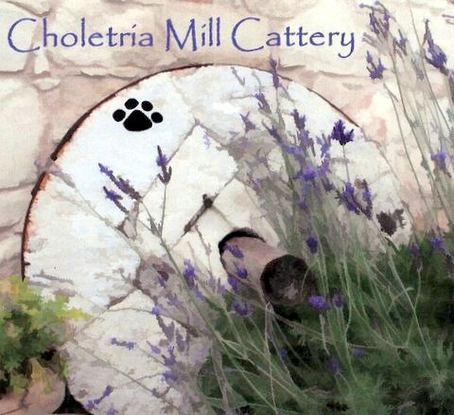 Choletria Mill Cattery

BOARDING INFORMATION

Name(s) of cat(s)………………………………………………………………………………………………….

Description of cat(s)…………………………………………………………………………………………….

Name & address of owner………………………………………………………………………………….

Tel No……………………………..Mobile…………………………Email………………………………………

Contact Tel No’s……………………………………………………………………………………………………

Period of stay: from…………………………………………To…………………………………………….

Description of personal items brought with cat(s) e.g. basket, blanket, toys etc…………………………………………………………………………………………………..

Food preference or special diet……………………………………………………………………….

Existing medical conditions, injuries, current treatment or medicines…

……………………………………………………………………………………………………………………………………..

Veterinary appointments………………………………………………………………………………………

Veterinary surgeon…………………………………………………………………………………………………

Signature of Owner………………………………………………………………………………………………..

Print Name………………………………………………………………………………………………………………..

Date…………………………………………………………………………………………………………………………….

Anita Edwards Tel: Mobile: 00357 99421674
Email: themillcattery@hotmail.com
Web: www.choletriamillcattery.com

